**RHEL6 BOOT PROCESS FLOW CHART**

1. **BIOS (BASIC INPUT OUTPUT SYSTEM)**

**(POST= Power on Self-Test = Check and initialize all the peripherals and components of your computer system)  
  
2. MBR (Master Boot Record)  
3. GRUB2 Bootloader  
4. Kernel (Check and initialize your HW, loads the root fs read only, Loads the init Process)  
5.Init (Initialization Process, initializes your system, It is the first process when we boot the system, It has a PID of 1)**

**/etc/rc.d/rc.sysinit => System initialization script is run**

**Loads the default runlevel**

**Default runlevel is defined in /etc/inittab file**

**Runlevel specific script are run based on the default run level**

**Selected = /etc/rc,d<rc.<runlevel>.d)**

**Check and mount all the partitions from /etc/fstab**

**6.Runlevel ( State of the OS)**

**Run Levels:**

* Runlevel 0 -> poweroff
* Runlevel 1 -> rescue single user mode
* Runlevel 2 -> multi-user without NFS, NW
* Runlevel 3 -> multi-user ( Full Multiuser with

NFS, NW no GUI) CLI login

Runlevel 3 is default runlevel in servers

CLI=Command line Interface only text login

GUI=Graphical User Interface

* Runlevel 4 -> multi-user (configurable)
* Runlevel 5 -> graphical ( Full Multiuser with

NFS, NW and GUI)

Default login in desktops and clients

* Runlevel 6 -> reboot

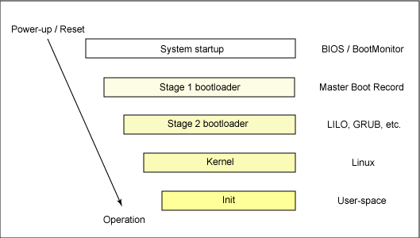

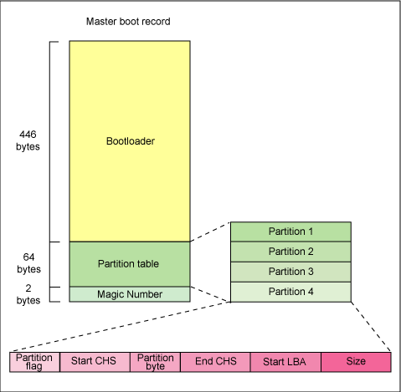

***BOOTLOADER***

**LILO** =Linux Loader

**GRUB**=Grand Unified Boot Loader